1. ReactJS-HOL

App.js

*function* App() {

  return(

    <h1>Welcome to the first session of React</h1>

  );

}

export default App;

Output:

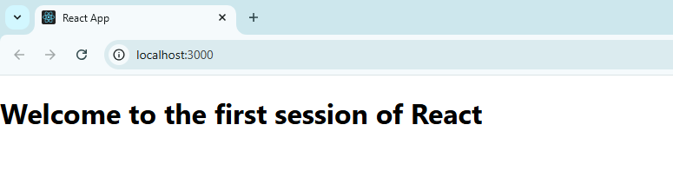

1. ReactJS-HOL

Home.js

import React, { Component } from 'react';

*class* Home extends Component {

  render() {

    return (

      <div>

        <h3>Welcome to the Home Page of Student Management Portal</h3>

      </div>

    );

  }

}

export default Home;

About.js

import React, { Component } from 'react';

*class* About extends Component {

  render() {

    return (

      <div>

        <h3>Welcome to the Home Page of Student Management Portal</h3>

      </div>

    );

  }

}

export default About;

Contact.js

import React, { Component } from 'react';

*class* Contact extends Component {

  render() {

    return (

      <div>

        <h3>Welcome to the Home Page of Student Management Portal</h3>

      </div>

    );

  }

}

export default Contact;

Output:

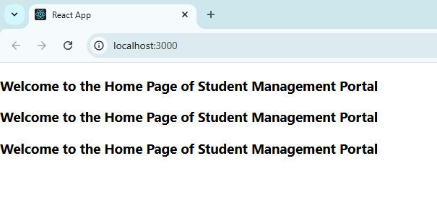

1. ReactJS-HOL

CalculatorScore.js

import '../Stylesheets/mystyle.css';

*const* percentToDecimal = (*decimal*) *=>* {

  return (*decimal* \* 100).toFixed(2) + '%'; // Multiply by 100 to convert to percentage

};

*const* calcScore = (*total*, *goal*) *=>* {

  return percentToDecimal(*total* / *goal*);

};

export *const* CalculateScore = ({ *Name*, *School*, *total*, *goal* }) *=>* (

  <div className="formatstyle">

    <h1><font color="Brown">Student Details:</font></h1>

    <div className="Name">

      <b><span>Name:</span></b>

      <span>{*Name*}</span>

    </div>

    <div className="School">

      <b><span>School:</span></b>

      <span>{*School*}</span>

    </div>

    <div className="Total">

      <b><span>Total:</span></b>

      <span>{*total*}</span>

      <span> Marks</span>

    </div>

    <div className="Score">

      <b>Score:</b>

      <span>{calcScore(*total*, *goal*)}</span>

    </div>

  </div>

);

mystyle.css

.Name

{

*font-weight*: 300;

*color*: blue;

}

.School

{

*color*: crimson;

}

.Total

{

*color*: darkmagenta;

}

.formatstyle

{

*text-align*: center;

*font-size*: large;

}

.Score

{

*color*: forestgreen;

}

App.js

import { CalculateScore } from './components/CalculatorScore';

*function* App() {

  return (

    <div>

      <*CalculateScore*

        Name="Steeve"

        School="DNV Public School"

        total={284}

        goal={300}

      />

    </div>

  );

}

export default App;

Output:

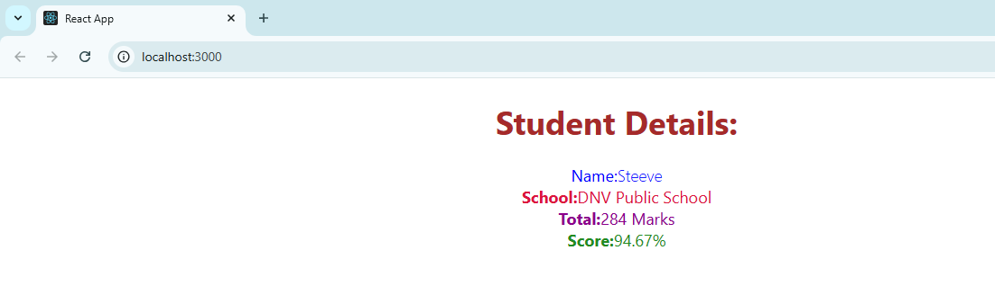

1. ReactJS-HOL

Post.js

*class* Post

{

*constructor*(*id*,*title*,*body*)

    {

        this.id=*id*;

        this.title=*title*;

        this.body=*body*;

    }

}

export default Post;

Posts.js

// src/Posts.js

import React, { Component } from 'react';

*class* Posts extends Component {

*constructor*(*props*) {

    super(*props*);

    this.state = {

      posts: [],

      hasError: false

    };

  }

  loadPosts = () *=>* {

    fetch('https://jsonplaceholder.typicode.com/posts')

      .then((*response*) *=>* {

        if (!*response*.ok) throw new *Error*('Failed to fetch posts');

        return *response*.json();

      })

      .then((*data*) *=>* {

        this.setState({ posts: *data* });

      })

      .catch((*error*) *=>* {

        this.setState({ hasError: true });

        console.error("Fetch error:", *error*);

      });

  };

  componentDidMount() {

    this.loadPosts();

  }

  componentDidCatch(*error*, *info*) {

    this.setState({ hasError: true });

    alert('An error occurred: ' + *error*.toString());

    console.error("Error caught by componentDidCatch:", *error*, *info*);

  }

  render() {

    if (this.state.hasError) {

      return <h2>Error loading posts. Please try again later.</h2>;

    }

    return (

      <div style={{ padding: '20px' }}>

        <h2>Posts</h2>

        {this.state.posts.map((*post*) *=>* (

          <div key={*post*.id} style={{ marginBottom: '20px' }}>

            <h3>{*post*.title}</h3>

            <p>{*post*.body}</p>

          </div>

        ))}

      </div>

    );

  }

}

export default Posts;

App.js

// src/App.js

import React from 'react';

import Posts from './Posts';

*function* App() {

  return (

    <div className="App">

      <*Posts* />

    </div>

  );

}

export default App;

Output:

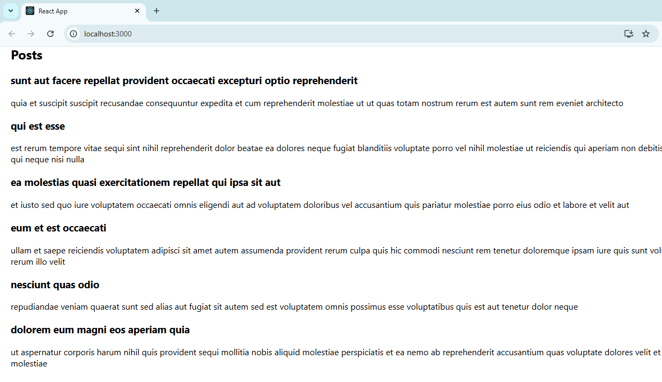

1. ReactJS-HOL

CohortDetails.module.css:

.box {

*width*: 300px;

*display*: inline-block;

*margin*: 10px;

*padding*: 10px 20px;

*border*: 1px solid black;

*border-radius*: 10px;

}

dt {

*font-weight*: 500;

}

CohortDetails.js:

import React from 'react';

import styles from './CohortDetails.module.css';

*function* CohortDetails(*props*) {

*const* isOngoing = *props*.cohort.currentStatus === 'Ongoing';

    return (

        <div className={styles.box}>

            <h3 style={{ color: isOngoing ? 'green' : 'blue' }}>

                {*props*.cohort.cohortCode} -

                <span> {*props*.cohort.technology}</span>

            </h3>

            <dl>

                <dt>Started On</dt>

                <dd>{*props*.cohort.startDate}</dd>

                <dt>Current Status</dt>

                <dd>{*props*.cohort.currentStatus}</dd>

                <dt>Coach</dt>

                <dd>{*props*.cohort.coachName}</dd>

                <dt>Trainer</dt>

                <dd>{*props*.cohort.trainerName}</dd>

            </dl>

        </div>

    );

}

export default CohortDetails;

Output:

